Ideation Phase

Brainstorm & Idea Prioritization Template

|  |  |
| --- | --- |
| Date | 04 NOVEMBER 2022 |
| Team ID | PNT2022TMID11798 |
| Project Name | Real time water quality monitoring and control  system |
| Maximum Marks | 4 Marks |

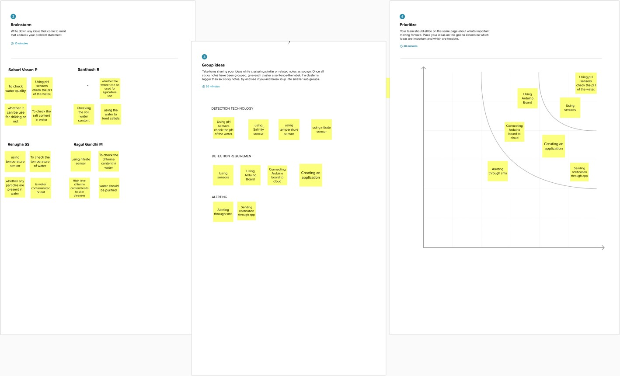

Reference

Link: [https://app.mural.co/t/jansonsinstituteoftechnology4907/m/jansonsinstituteoftechnology4907/](https://app.mural.co/t/jansonsinstituteoftechnology4907/m/jansonsinstituteoftechnology4907/1667291493071/79a003d9d510bb8568c2a96dd381703ca09a8785?sender=u2c4a924bc47b96ea2ce80112) [1667291493071/79a003d9d510bb8568c2a96dd381703ca09a8785?sender=u2c4a924bc47b96](https://app.mural.co/t/jansonsinstituteoftechnology4907/m/jansonsinstituteoftechnology4907/1667291493071/79a003d9d510bb8568c2a96dd381703ca09a8785?sender=u2c4a924bc47b96ea2ce80112) [ea2ce80112](https://app.mural.co/t/jansonsinstituteoftechnology4907/m/jansonsinstituteoftechnology4907/1667291493071/79a003d9d510bb8568c2a96dd381703ca09a8785?sender=u2c4a924bc47b96ea2ce80112)